**B.B.A. SEMESTER - IV**

**INCOME TAX – LAW AND PRACTICE**

**UNIT 1 INTRODUCTION, RESIDENTIAL STATUS AND EXEMPT INCOME**

**CHAPTER 2 RESIDENTIAL STATUS AND INCIDENCE OF TAX**

**Introduction**

* The INCIDENCE OF TAX on any assessee depends upon his RESIDENTIAL STATUS under the Income-tax Act, 1961.
* For all purposes of Income-tax, Individuals and HUFs are classified into three broad categories, on the basis of their residential status, viz.

1. Resident and ordinarily resident (R&OR)
2. Resident but not ordinarily resident (RBNOR)
3. Non-resident (NR)

All other persons (other than individual and HUFs) are classified into-

1. Resident (R)
2. Non-resident (NR)

* Residential status must be ascertained in respect of each **previous year** and then, income calculation should be done accordingly.
* *The residence of an individual for income-tax purpose has nothing to do with citizenship, place of birth or domicile (permanent residence).*

**Determination of Residential Status of an Individual**

* As per Section 6(1) of the Income-tax Act, 1961, an individual is said to be **RESIDENT** in India in any previous year, if he satisfies **any ONE** of the following conditions [Also termed as **BASIC CONDITIONS**]:

1. He has been in India during the previous year for a total period of **182 days or more**, **OR**
2. He has been in India during the immediately preceding 4 years for a total period of **365 days or more** AND has been in India for **at least 60 days in the previous year**

* For the following category of persons, only 1st condition shall be applicable to treat the person as a resident:
* Indian citizens, who leave India during the previous year as member of the crew of an Indian ship or for purpose of employment outside India, OR
* Indian citizen or *person of Indian origin* left India and who comes on a visit to India in any previous year

[*Person of Indian origin* is one, who himself or either of his parents or either of his grandparents, were born in undivided India]

* If an individual is **unable to satisfy ANY of the BASIC CONDITIONS**, he shall be **NON-RESIDENT** for the relevant previous year.
* Individuals and HUF, which are classified as resident, shall be further classified as Resident and Ordinary Resident and Resident but not Not-ordinary Resident.
* An individual is said to be a **RESIDENT AND ORDINARILY RESIDENT** if **both** the following conditions are satisfied [Also termed as **ADDITIONAL CONDITIONS**]:

1. He is a **resident in any 2 out of the last 10 years** preceding the relevant previous year, **AND**
2. His **total stay in India in the last 7 years** preceding the relevant previous year is **730 days or more**.

* If only *one* or *none* of the additional conditions are satisfied, individual shall be **RESIDENT BUT NOT ORDINARILY RESIDENT**.

***Note: The day of arrival in India and the day of leaving India are both regarded as two separate days and both are included in the calculation.***

**Determination of Residential Status of HUF**

* A HUF would be RESIDENT in India if the *control and management* of its affairs is situated wholly or partly in India.
* A HUF would be NON-RESIDENT in India if the control and management of its affairs is situated wholly outside India.
* The expression “control and management” refers to the central control and management and not to the carrying on of day-to-day business by servants, employees or agents. *Control and management is said to be situated at a place where the head and brain of the adventure is situated.*
* If the HUF is resident, then the status of the Karta shall determine whether it is RESIDENT AND ORDINARILY RESIDENT or RESIDENT BUT NOT ORDINARILY RESIDENT.

**Determination of Residential Status of Firms, AOPs, Local authorities, Artificial juridical persons**

* A Firm/ AOP/ Local authority/ Artificial juridical person would be RESIDENT in India if the control and management of its affairs is situated wholly or partly in India.
* A Firm/ AOP/ Local authority/ Artificial juridical person would be NON-RESIDENT in India if the control and management of its affairs is situated wholly outside India.

**Determination of Residential Status of Company**

* A company would be RESIDENT in India in any previous year, if

1. It is an Indian company, OR
2. Its Place of Effective Management [POEM] in that year is in India.

* An Indian company is always resident in India

**Scope of Total Income**

* As per Section 5(1) of the Income-tax Act, 1961; a RESIDENT AND ORDINARILY RESIDENT has to pay tax on the total income
* Accrued,
* Deemed to accrue,
* Received, OR
* Deemed to be received;

During the previous year in or outside India.

* As per Section 5(1) of the Income-tax Act, 1961; a RESIDENT BUT NOT ORDINARILY RESIDENT’s total income shall be same as that of resident and ordinarily resident, except the fact that income accruing outside India is not to be included in the total income. [If such income is derived from a business/ profession controlled from India, then it must be included].
* As per Section 5(2) of the Income-tax Act, 1961; a NON-RESIDENT has to pay tax on the total income
* Accrued,
* Deemed to accrue,
* Received, OR
* Deemed to be received;

During the previous year in India.

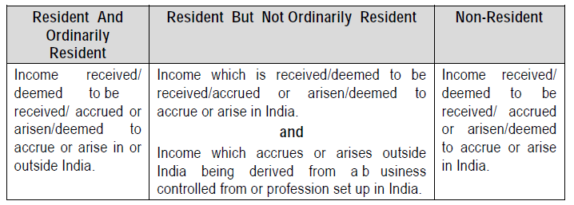

**Income deemed to be received**

* As per Section 7 of the Income-tax Act, 1961, the following shall be deemed to be received by the assessee during the previous year irrespective of whether he had actually received the same or not:

1. Annual accretion in the previous year by an employee in his recognized Provident Fund
2. Balance transferred from unrecognized to recognized Provident Fund, if it is taxable in nature
3. Contribution made by the Central Govt. or any other employer in the previous year to the employee under a Pension scheme.

**Income deemed to accrue**

* As per Section 9 of the Income-tax Act, 1961, the following categories of income are always deemed to accrue in India:

1. Any income accruing from any business connection or from any property or from any source of income in India [even if it arises outside India]
2. Income from Salary which is payable by the Govt. to a citizen of India for services rendered outside India
3. Dividend paid by an Indian company outside India
4. Interest
5. Royalty
6. Fees for technical services

*Illustration 1*

Mr. Ganesh was in India for the following period. Determine his residential status for A.Y. 2017-18.

Previous Year Presence in India

2016-17 182 days

2015-16 55 days

2014-15 28 days

*Illustration 2*

Steve Waugh, the Australian cricketer, comes to India for 100 days every year. Find out his residential status for A.Y. 2017-18.

*Illustration 3*

Mr. Bob, a US citizen, comes to India for the first time in P.Y. 2012-13. During the financial years 2012-13, 2013-14, 2014-15, 2015-16 and 2016-17, he was in India for 55 days, 60 days, 90 days, 150 days and 70 days, respectively. Determine his residential status for A.Y. 2017-18.

*Illustration 4*

Mr. Ramamurthy went to England on 5th August, 2016 and came back to India on 25th February, 2017. He had never been out of India before. What is his residential status for A.Y. 2017-18?

*Illustration 5*

Ms. Rose, a foreign national and a person of Indian origin, comes to India for the first time on 22/8/12 and left for Tokyo on 5/5/15. She once again arrived in India on 26/1/17 and left for China on 30/3/17. Determine her residential status for A.Y. 2017-18.

*Illustration 6*

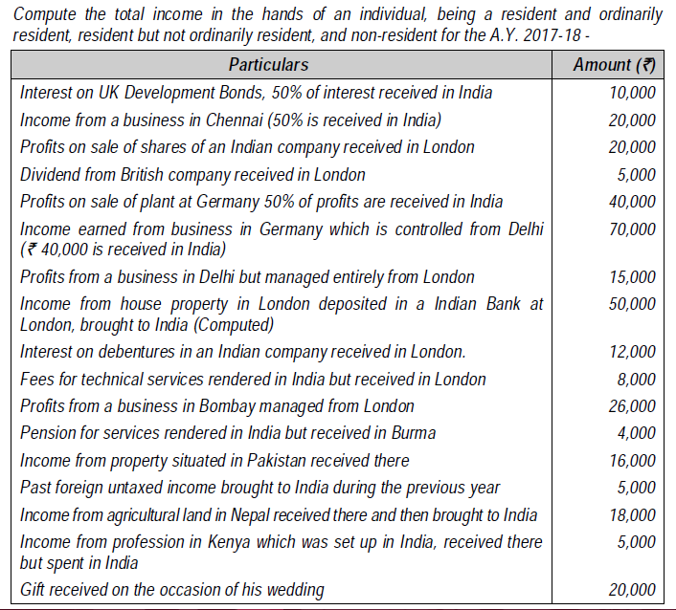

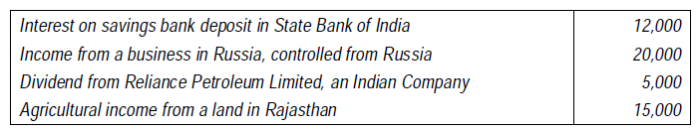

|  |  |  |  |
| --- | --- | --- | --- |
|  | R&OR | RBNOR | NR |
| 1. Interest on UK Development Bonds | 10,000 | 5,000 | 5,000 |
| 1. Income from business in Chennai (accrue or arise in India) | 20,000 | 20,000 | 20,000 |
| 1. Profit from sale of shares of Indian Company (Deemed to accrue or arise in India) | 20,000 | 20,000 | 20,000 |
| 1. Dividend form British Company | 5,000 | NIL | NIL |
| 1. Profit from sale of plant abroad | 40,000 | 20,000 | 20,000 |
| 1. Income from business in Germany (Controlled from India) | 70,000 | 70,000 | 40,000 |
| 1. Profit from business in Delhi (accrue or arise in India) | 15,000 | 15,000 | 15,000 |
| 1. Income form property in London | 50,000 | NIL | NIL |
| 1. Interest on Debentures in Indian Company (deemed to accrue or arise in India) | 12,000 | 12,000 | 12,000 |
| 1. FTS rendered in India (deemed to accrue or arise in India) | 8,000 | 8,000 | 8,000 |
| 1. Profit from business in Bombay (accrue or arise in India) | 26,000 | 26,000 | 26,000 |
| 1. Pension for services rendered in India | 4,000 | 4,000 | 4,000 |
| 1. Income from property in Pakistan | 16,000 | NIL | NIL |
| 1. Past untaxed income brought to India (remittance in India) | NOT TAXABLE | NOT TAXABLE | NOT TAXABLE |
| 1. Agriculture income in Nepal received there | 18,000 | NIL | NIL |
| 1. Income from profession in kenya setup in India | 5,000 | 5,000 | NIL |
| 1. Gift received on the occasion of marriage | EXEMPT | EXEMPT | EXEMPT |
| 1. Interest on SB AC with SBI | 12000 | 12000 | 12000 |
| 1. Income from business in Russia | 20,000 | NIL | NIL |
| 1. Dividend from Reliance Ltd. (Deemed to accrue or arise in India) | 5,000 | 5,000 | 5,000 |
| 1. Agriculture income in India | EXEMPT | EXEMPT | EXEMPT |
| TOTAL INCOME |  |  |  |